**Sophos AV Uninstallation & Confirmation for Microsoft Defender Activation Status Procedure**

**Note:**

**The user currently in Telework/WFH** - Start on Procedure item **number 1**

* Once all procedure steps are initiated, and machines restarted. It needs to connect to PH VPN for 2-3 Hours.

**The user currently in Onsite/Office (Using LAN Connection or if on WIFI, Connect to VPN)** - Proceed to Procedure item **number 2** (Skip **item number 1**).

**Procedure:**

**1. Connect to PH VPN.**

**2. Open Command Prompt or type CMD in search bar**

3. Type GPUPDATE/FORCE, then hit ENTER Key in your Keyboard

4. Once the result of procedure item number 3 is successful, restart your Machine

5. After restart, you will be prompted to re-login your g07 account.

A. Enter your g07 username and password

B. Authenticate your log-in by approving a request from Microsoft Authenticator from your phone.

6. If procedure number item 3 result is not Successful, please contact InfoSec by sending email to [phgdcitinfosec@fujitsu.com](mailto:phgdcitinfosec@fujitsu.com)

**How to confirm that Sophos AV is uninstalled.**

1. Sophos AV icon is not present in Machine System Tray ().

**How to confirm that Microsoft Defender is Activated.**

Note: The Microsoft Defender will only activate once the Sophos AV application removes completely.

1. Go to your System tray and hover your mouse pointer to Windows Security. Double click the Shield icon. 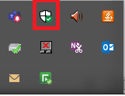
2. Fujitsu Support is indicated in Windows Security ()

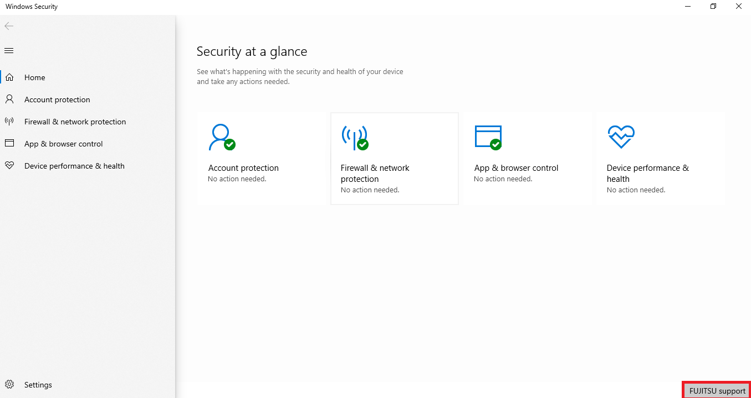

End.